Application Form 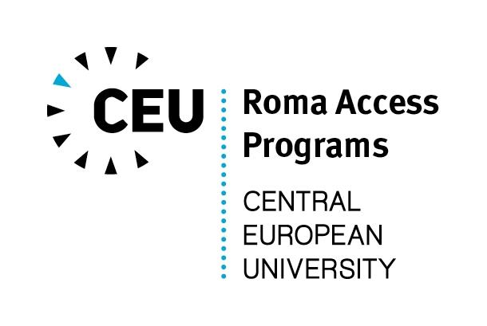
Roma Graduate Preparation Program 2014-2015

Personal Information

Are you Roma? __________
Given/First Name: ____________________________________________________________________
Family/Last Name: ____________________________________________________________________
Place and date of birth: ____________________________________________________________________
Mailing address: ____________________________________________________________________
Telephone: _________________________________________
E-mail address: _________________________________________

Education

Year of graduation from university: ____________________________________________________________
Full title of Bachelor’s degree: ________________________________________________________________
Name and location of university: ______________________________________________________________

Which subjects are you interested in studying during the RGPP? (Please underline one or two)
Economics Mathematics
Environmental Science and Policy Nationalism Studies
Gender Studies Philosophy
History Political Science
International Relations and European Studies Public Policy
Legal Studies/Human Rights Sociology and Social Anthropology
Other (please, specify): ____________________________

English language skills
(Please indicate your level of English language knowledge by crossing the appropriate box)

Beginner | Pre-Intermediate | Intermediate | Upper-Intermediate | Advanced

How did you find out about this program? (Please underline)
RAP website RAP mailing list
RAP Facebook page Your University
Former student of RAP Local Open Society Foundation
Announcement from a mailing list or another electronic source (please specify): _________________________________________________________________________________________
Other (please specify): ______________________________________________________________________

What would be your goal after the completion of this program? (Please underline)

1. Post-Graduate Studies (MA, PhD) 2. Work at an NGO 3. Work in Business 4. Work in government 5. Other

______________________ __________________________
Date Signature

Please send your application by 13 April 2014 by e-mail OR post to:
E-mail: rgpp@ceu.hu
Postal address: Central European University, Roma Access Programs, Nador u. 9, H-1051 Budapest, Hungary

